**EXPERIMENT 7-8 Date: 24th March 2023**

**TITLE:** **Nested SQL queries or Subqueries**

**OBJECTIVE:** To understand the use SQL Subquery

1. **Create Tables (EMP and DEPT)**

CREATE TABLE DEPT (

DEPTNO INTEGER PRIMARY KEY,

DNAME VARCHAR(20),

LOC VARCHAR(20)

);

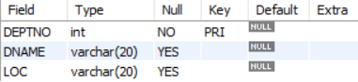

CREATE TABLE EMP (

EMPNO INTEGER PRIMARY KEY,

EMPNAME VARCHAR(20),

JOB VARCHAR(20),

MGR INTEGER,

HIREDATE DATE,

SAL INTEGER,

COMM INTEGER,

DEPTNO INTEGER,

FOREIGN KEY(DEPTNO) REFERENCES DEPT(DEPTNO)

);

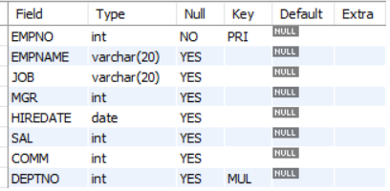

INSERT INTO DEPT VALUES (10, 'ACCOUNTING', 'NEW YORK');

INSERT INTO DEPT VALUES (20, 'RESEARCH', 'DALLAS');

INSERT INTO DEPT VALUES (30, 'SALES', 'CHICAGO');

INSERT INTO DEPT VALUES (40, 'OPERATIONS', 'BOSTON');

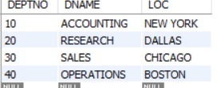

INSERT INTO EMP VALUES(7369 ,'SMITH','CLERK',7902,'1980-12-17',800,NULL,20);

INSERT INTO EMP VALUES(7499 ,'ALLEN','SALESMAN',7698,'1981-02-20',1600,300,30);

INSERT INTO EMP VALUES(7521 ,'WARD','SALESMAN',7698,' 1981-02-22',1250,500,30);

INSERT INTO EMP VALUES(7566, 'JONES','MANAGER',7839,' 1981-04-02',2975 ,NULL,20);

INSERT INTO EMP VALUES(7654, 'MARTIN','SALESMAN',7698 ,'1981-09-28',1250,1400,30);

INSERT INTO EMP VALUES(7698, 'BLAKE','MANAGER',7839,' 1981-05-01',2850,NULL,30);

INSERT INTO EMP VALUES(7782, 'CLARK','MANAGER',7839 ,'1981-06-09' ,2450 ,NULL,10);

INSERT INTO EMP VALUES(7788, 'SCOTT','ANALYST', 7566 ,'1987-04-19' ,3000 ,NULL,20);

INSERT INTO EMP VALUES(7839, 'KING','PRESIDENT',NULL, '1981-11-17', 5000,NULL,10);

INSERT INTO EMP VALUES(7844, 'TURNER','SALESMAN',7698,'1981-09-08',1500,0,30);

INSERT INTO EMP VALUES(7876, 'ADAMS','CLERK',7788,'1987-05-23',1100 ,NULL,20);

INSERT INTO EMP VALUES(7900, 'JAMES','CLERK',7698, '1981-12-03', 950 ,NULL,30);

INSERT INTO EMP VALUES(7902, 'FORD','ANALYST',7566, '1981-12-03',3000 ,NULL,20);

INSERT INTO EMP VALUES(7934, 'MILLER','CLERK',7782, '1982-01-23',1300 ,NULL,10);

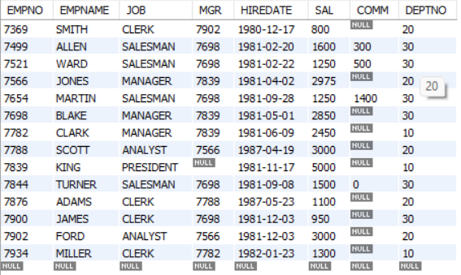

1. **Write the Nested Queries for the following queries.**
2. **List the details of the emps whose Salaries more than the employee BLAKE.**

SELECT * FROM EMP WHERE SAL >

(SELECT SAL FROM EMP WHERE EMPNAME = "BLAKE");

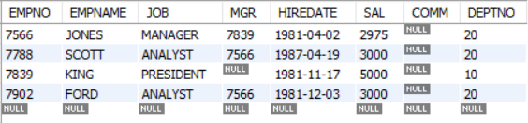

1. **List the emps whose Jobs are same as ALLEN.**

SELECT EMPNAME FROM EMP WHERE JOB =

(SELECT JOB FROM EMP WHERE EMPNAME = "ALLEN");

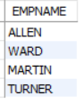

1. **List the Emps whose Sal is same as FORD or SMITH in DESC order of Names.**

SELECT EMPNAME FROM EMP WHERE SAL IN

(SELECT SAL FROM EMP WHERE EMPNAME IN ('FORD', 'SMITH')) ORDER BY EMPNAME DESC;

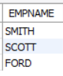

1. **List the emps Whose Jobs are same as MILLER or Sal is more than ALLEN.**

SELECT EMPNAME FROM EMP WHERE SAL >

(SELECT SAL FROM EMP WHERE EMPNAME = "ALLEN")

OR JOB = (SELECT JOB FROM EMP WHERE EMPNAME = "MILLER");

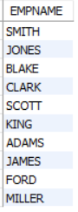

1. **Find the highest paid employee of sales department.**

SELECT EMPNAME FROM EMP WHERE SAL =

(SELECT MAX(SAL) FROM EMP WHERE DEPTNO IN

(SELECT DEPTNO FROM DEPT WHERE DNAME = "SALES")

AND DEPTNO = (SELECT DEPTNO FROM DEPT WHERE DNAME = 'SALES'));

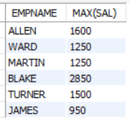

1. **List the employees who are senior to most recently hired employee working under king.**

SELECT EMPNAME FROM EMP WHERE HIREDATE <

(SELECT MAX(HIREDATE) FROM EMP WHERE MGR IN

(SELECT EMPNO FROM EMP WHERE EMPNAME = "KING"));

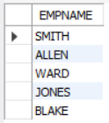

1. **List the names of the emps who are getting the highest sal dept wise.**

SELECT EMPNAME, DEPTNO FROM EMP,

(SELECT MAX(SAL) AS M, DEPTNO AS D FROM EMP GROUP BY DEPTNO) as MD

WHERE SAL = MD.M AND DEPTNO = MD.D;

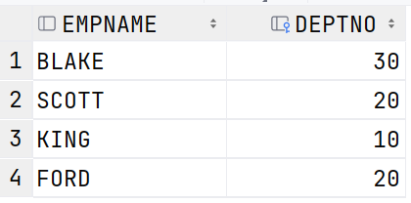

1. **List the emps whose sal is equal to the average of max and minimum**

SELECT * FROM EMP WHERE SAL =

(SELECT (MAX(SAL) + MIN(SAL)) / 2 FROM EMP);



1. **List the emps who joined in the company on the same date.**

SELECT * FROM EMP AS E WHERE HIREDATE IN

(SELECT HIREDATE FROM EMP WHERE E.EMPNO <> EMPNO);



1. **Find out the emps who joined in the company before their managers.**

SELECT EMPNAME FROM EMP E WHERE HIREDATE <

(SELECT HIREDATE FROM EMP WHERE EMPNO = E.MGR);

